

ST KIERAN CATHOLIC PRIMARY SCHOOL

School Performance Information

2020

**PART 1: Publication of Information Relating to Schools** **3**

Contextual Information 3

Teacher standards and qualifications 3

**Workforce composition** **4**

Student attendance at school 5

**2020 Attendance by Year Level** **5**

NAPLAN information 6

Parent, student and teacher satisfaction 6

School Income 6

School Improvement 7

**PART 2: School Community Report** **8**

# PART 1: Publication of Information Relating to Schools

## Contextual Information

St Kieran Catholic Primary School is a co-educational primary school located on the fringe of the Perth city centre. Established in 1920 by the Sisters of Mercy the School has progressed from a staff of two Sisters of Mercy teaching 100 students to a school that now caters for over 480 students from Pre-Kindergarten to Year 6.

The school offers a comprehensive learning program with support and extension opportunities available for all students. Our focus also extends to a special commitment to children with disabilities. The school has an Educational Support Centre that provides a variety of intervention programs in both a support and mainstream setting. The school also houses the only Early Intervention Centre in the WA Catholic System. This Centre supports students (and their families) who have a disability, are aged between three and six years old and who are enrolled in another Catholic school.

The school assists parents in preparing each child to contribute positively to their local community, having a particular awareness of the needs of, and responsibility to, the wider Church. A strong working relationship has been established with the Parish to support all students and families.

The St Kieran mission declares our core purpose as a school and guides our planning and decisions. In the footsteps of our founders, the Sisters of Mercy, our mission is to inspire a love of learning, personal excellence and a constant and faith-filled commitment to justice.

As a learning community centred on the example of Christ, the following core values underpin our approach;

Striving for personal **EXCELLENCE** and taking **RESPONSIBILITY** for our actions.

Living as Jesus would want with a commitment to **JUSTICE** and **COMPASSION**.

Creating a community where **RESPECT** and **BELONGING** are experienced by all.

## 

## Teacher Standards and Qualifications

It should be noted that staff may hold a number of different qualifications and these numbers reflect all qualifications held by all teachers who taught in the school over 2020 including those who replaced staff on long term leave.

|  |  |
| --- | --- |
| ***Qualification*** | ***Number holding the qualification*** |
| *Bachelor of Arts - Early Childhood Education* | *1* |
| *Bachelor of Arts* | *4* |
| *Bachelor of Arts in Education* | *5* |
| *Bachelor of Education* | *20* |
| *Bachelor of Education (Primary)* | *3* |
| *Bachelor of Education in Early Childhood Education* | *1* |
| *Diploma in Religious Education* | *1* |
| *Diploma in Teaching* | *9* |
| *Master of Educational Leadership* | *1* |
| *Master of Religious Education* | *1* |
| *Bachelor of Social Science* | *1* |
| *Certificate in Business Studies* | *1* |
| *Graduate Diploma in Education* | *3* |
| *Graduate Diploma in Early Childhood Education* | *1* |
| *Master of Education* | *1* |
| *Certificate III Teaching Assistant* | *1* |
| *Certificate IV Teaching Assistant* | *1* |

## Workforce Composition

|  |  |  |  |  |
| --- | --- | --- | --- | --- |
| ***Staff*** | ***Female*** |  | ***Male*** |  |
|  | ***Indigenous*** | ***Non Indigenous*** | ***Indigenous*** | ***Non Indigenous*** |
| ***Full Time Teaching*** |  | *16* |  | *3* |
| ***Part Time Teaching*** |  | *12* |  | *0* |
| ***Full Time Non-teaching*** |  | *11* |  | *0* |
| ***Part Time Non-teaching*** |  | *22* |  | *3* |

Note: The above figures include all staff who worked in the school in 2020. This includes staff who replaced contracted staff on various types of long term leave.

## Student Attendance at School

Attendance is monitored using the attendance system within the Seqta suite. Reports are generated daily to confirm attendance. Parents use a voice messaging facility, or an app generated absentee form, to report student absences. The school contacts parents early each school day to follow up unexplained school absences via text message, requiring parents to make contact with the school office to explain a student’s absence. Where no interaction from parents is received this is followed by a further text and then a phone call.

Parents are contacted when attendance over a term or semester percentage falls below 90% and these students are monitored during the school year. Where attendance does not improve the school commences a dialogue with the parents to determine the cause of the absences and whether this can be easily rectified. If necessary, an attendance improvement plan will be put into place, involving different stakeholders including parents, staff and external agencies if appropriate.

The high number of children with a disability in the school does affect the overall percentage attendance of the school as a number who do attend therapy during the school day, when it is unavoidable. A number of students also have medical needs that affect their ongoing school attendance. The school works with these parents to support student’s needs within the school setting wherever possible to ensure attendance is maintained at the highest level possible.

## 2020 Attendance by Year Level

|  |  |
| --- | --- |
| Year Level | % of attendance |
| PP | **90.95%** |
| Y01 | **93.24%** |
| Y02 | **93.03%** |
| Y03 | **90.57%** |
| Y04 | **93.56%** |
| Y05 | **92.84%** |
| Y06 | **94.17%** |
| Total School Attendance | **92.62%** |

## 

## NAPLAN Information

Due to the COVID-19 pandemic. NAPLAN assessments were not administered in 2020, therefore no data is present.

## Parent, Student and Teacher Satisfaction

The school uses a range of different approaches to determining school satisfaction including surveys, focus groups various meetings for parents and staff, opportunities for student's voice through school leadership groups and via Kieran Connect and School advisory Committee for decision making regarding the spending of school resources for student use.

There are multiple opportunities for parents and staff to offer feedback either in person or through digital responses. On most occasions, feedback is both positive and proactive in where the school is focussing its efforts.

Staff are provided with multiple individual, year level and whole group opportunities to shape the direction of the school and their own learning. This occurs several times each year and is a reflective opportunity to maintain the positives, acknowledge the areas needing removal or change and looking at new opportunities to meet the ever-changing needs of our students. This information is used in determining new strategic directions through the annual school improvement plan.

## School Income

https://www.myschool.edu.au/school/48950/finances

## School Improvement

**Annual School Improvement Plan - Success Measures**

* Implemented Letters and Sounds in K-3 as the synthetic phonics program expected to be used in the school
* Talk4Writing used in each Year level from K-6
* Embedded the MiniLt Programs as the Literacy Intervention Models for Yr1 -6
* Continued to develop and utilise the physical space within the school to enhance the learning program.
* 1, 2, 3 Magic implemented across the school to supplement the current Behaviour Management Plan.

Note: these items have committed to be focus points in 2021 due to the COVID19 interruptions on the school site.

# PART 2: School Community Report

*At the 2020 AGM breakdown of the 2021 school budget was presented. In response to COVID and as directed by Catholic Education Western Australia there was no increase of school fees. We have attempted to construct a budget that meets the needs of our school community both in service and cost. A breakdown of the percentage income and expenditure is shown below*

*Expected Percentage income for 2021*

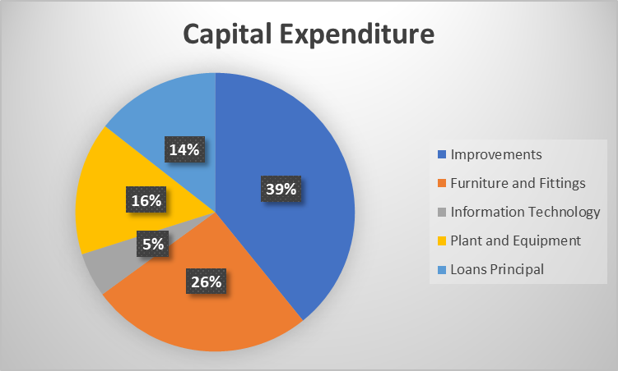

*Expected Percentage Recurrent Expenditure for 2021*

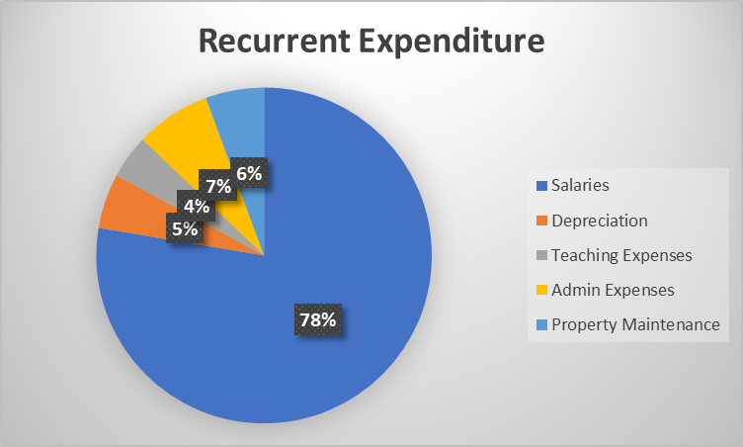

*Expected Percentage Capital Expenditure for 2021*

**



## 